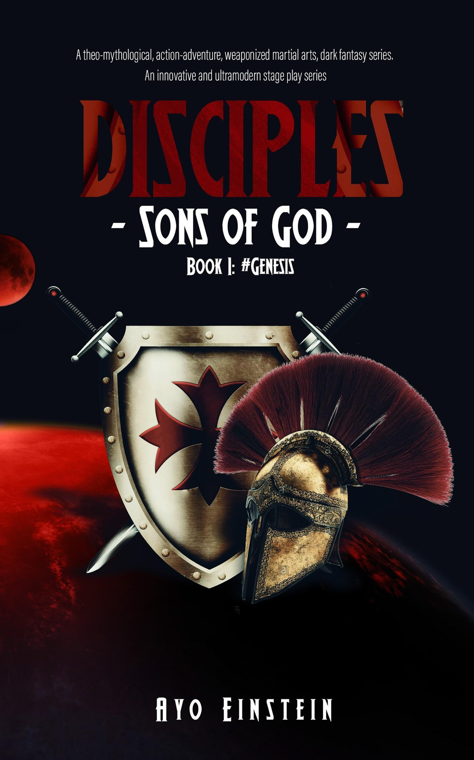

AYO EINSTEIN
DISCIPLES
(SONS OF GOD)

COPYRIGHT

Copyright © Ayo Einstein, 2022
All rights reserved. This book or any portion of it may not be used, reproduced, sold, resold, lent, copied, hired out or otherwise circulated in any form without a signed, written consent from the publisher.
Asides from characterizing, reenacting and referencing actual historical figures, places and events, tweaked or altered, for the purpose of entertainment in the genre of alternate history and fantasy, all other subsequent names, places and characters are the product of the author’s imagination; and any resemblance to any persons living or dead is entirely coincidental.
First published in 2022.
ayoeinstein@gmail.com
www.ayoeinstein.wordpress.com

DISCIPLES
(SONS OF GOD)
“All Creation; anxiously and earnestly wait in eager anticipations for the cryptic unveiling of the Sons of God” - Romans 8:19 (paraphrased).

PREVIEW COPY

SCENE: ILE-IFE, OODUA REPUBLIC, AFRICA; (UNIVERSITY OF ILE-IFE). YEAR 2250, RETRO-FUTURISTIC EARTH.

Stage C: Ivy league academic lecture theater at Ile-ife, Oodua republic capital.
Digitally advanced and cultured students from all over the continent of Africa are present, wearing respective traditional outfits laced in luminous embroideries, accessories, jewelry and tech-couture at this prestigious, ivy league, pan african university lecture hall: ORANMIYAN theater. Continental tribes such as Xhosa, Zulu, Kikuyu, Maasi, Asante, Fante, Hadzabe, Mbulu, Fula, Dyula… and neighboring ones as Isoko, Ijaw, Urhobo, Igbo, Tiv, Edo (Benin)... and (predominantly) Yoruba are vastly, rich and culturally represented.
With blinking earpods on, wearing wrist smartphones, writing on foldable tablets with stylus pens, these students take notes during this live and also video-conferenced lecture, lectured by prominent professor of history, comparative studies and mysticism, Professor Akinwande Soyinka.
Live projection of the professor as he teaches is broadcasted on Screen A; multiple split screens of students attending this lecture live via video conference on B and C.
PROF. SOYINKA: …and that, students is how the amalgamation of the country ended; hence the title of the digital book “There Was A Country”. Questions?
A show of hands from the students, the professor points one out.
LEOPOLD: (french) salutations professeur, où d'autres peut-on avoir une perspective de première main sur la dissolution de l'ancien monde? (greetings professor, where else can one get a firsthand perspective on the dissolution of the old world?)
PROF SOYINKA: (answering in french) monsieur Leopold; right? International student; Senegal; scholarship?
LEOPOLD: yes sir.
PROF. SOYINKA: many events about the old country personally experienced, are festooned in my autobiography, “Ake: years of my childhood.”
AYINKE: ({nervous} Yoruba) sir, …can I… address you in ijebu… or egba?
PROF. SOYINKA: (Yoruba) young woman, none of these am I uncomfortable with, but for the sake of seamless translations despite the “efficacies” of our translating devices… As Mystics, we believe Science isn’t unfailing. Afterall, Science in itself states “no transformation of energy is hundred percent…” in the same vein, no translation of language is; …especially if by same “scientific” means. So, my dear, let's continue conversing in this conventional, interpretable yoruba.
AYINKE: your book, Death and the four horsemen…
PROF. SOYINKA: my thesis on this Apocrypha will be illumined next session in advanced classes.
OSOSE: sir; is Magic, science? Or Science, magic?
PROF. SOYINKA: Osose; always and ever with the ambiguous questions. Questions as these are what keeps us looking onto the stars for the unknown. And from known stars, we try to science the unknown. Life is cyclic-repeated sequences of helixed patterns, hence the statement “history repeats itself”. From history known, we prepare for a similar present; and if unsimilar, we seek similarities within its patterns to proffer similar resolutions. But what fool is one, if from known history fails tests repeat…? Hmm… the old country, the amalgamation… there was a country.
BIANCA: professor… sir…. intellectually, you’re now sailing too deep; becoming even astral beyond our scope.
ATIOKWU: blame Osose, her questionings spirals everyone into whirlpools of intelligentsia madness.
OSOSE: don’t hate on “curiosity’, no fault of mine my mind has gargantuan appetites for intelligence.
MENSAH: (in pronounced ghanian accent) then please save this ‘yea’ appetite for ‘yea’ Benin people.
PROF. SOYINKA: apologies for the divergence… from what known, succinctly put within the scope of the known unknown, Science is explainable magic, Magic is inexplicable science.
OSOSE: so which would we say is greater?
PROF. SOYINKA: hmm… interesting… Many have debated, many still debate this. At the end, it falls upon personal convictions and relative beliefs. But we have as FACTS, no powerful nation or enduring civilization has been built solely by magic… except… in fairytales and fantasy lore of course. Great civilizations have been built by progressive industries, innovations, technologies… basically Science. But does Science negate the existence of mysticism? No, emphatic No. Science defeats itself with its own axiom validating Mysticism. It states “energy neither can be created nor destroyed” if it can’t be destroyed nor created, it’s an existing, everlasting and imperishable force… or… forces since there are of various forms, integrated and even interchangeable, therefore, Science is subset of Mysticism and Mysticism expresses its form… or forms through Science.
OSOSE: sir, as a student of magical arts and sciences, what is the scope of our discipline?
PROF. SOYINKA: mystical arts and science is the analytical and controlled study of energies and forces, their various, varying and interchangeable forms whilst yielding one’s spirit, mind, intellect, emotions, soul and even body to the art. Mystical science believes that the total surrender of one’s being to intangible, imperishable power… or powers gives them access to unlimited energy or energies even as far as to do the humanly unnatural.
OSOSE: via astral projections sir?
PROF. SOYINKA: (chuckles) technically, by Esotericism; also known as Arcane. Astral projection is one of the subjects, methods and techniques of these studies.
OSOSE: sir–
YIHANA: You no dey taya?
OKONKWO: (igbo language) E be like say you wan collect abi?
KWHESI: Sir, regarding esotericism, topics like cosmology, demonology, theology–
PROF. SOYINKA: Esotery, mythology and higher pseudosciences will be covered in further and advanced classes.
BUZZER
A caller from the telecast on screen.
ANDWELE: sir, Andwele calling in from Tanzania. Immortality: incarnation, reincarnation…
PROF. SOYINKA: the poem “Abiku” reincarnation was…
BUZZER SOUNDS (END OF CLASS)
“On that note, we end this class. (touching his earpod) okay… okay… Osose, it's been brought to my attention that armed guards from Benin are present on the campus to see you. So class, this ends the semester, see you next session.”
Class ends, video conference screens are switched off, Professor Akinwande Soyinka on his hoverboard scoots off stage leftwards. Most students start to exit.
“Going to Senegal… by air, or the ultra Hyperloop?”
“Business class ticket price of Mandela airline… or the Elon pods?”
Some students, conversing through their wrist smartphones.
“My first class luxury pod leaves in fifteen minutes, should be in Nairobi in an hour and half.”
“What’s the recent rate of the Oodua crypto-cowries? Yes, yes …in Rands, Cedis and Francs?”
International students walk to understage exit portals and exit (via Hyperloops). Proximity students and locals exit on foot and scooters.
***
Stage is less dense with student activities at Stage C.
Eight Benin guards walk in from the left stage, two leading in front, the remaining six in parallel pairs walk right after. Light skinned, attractive and tall Osose walks up to them as they approach the edge of Stage C.
OSOSE: (surprised) Odion! Akhere! What rises the matter that the Oba would send top military guards to visit me?
ODION: Princess, there are matters arising concerning the royal family’s security that require immediate attention.
AKHERE: matters that must be attended to immediately. Your security and presence is needed at the palace.
ODION: we tried to call you for several days but your phone was switched off.
OSOSE: I left it so, I need no disturbances while I devote myself to higher learnings.
ODION: disturbance? It’s a means of communication for your own safety?
OSOSE: and who says I’m not safe?!?
AKHERE: (emphatically) Oba Ovonramwen Nogbaisi.
OSOSE: I’m not a little girl anymore, you know?
AKHERE: (calmer) your father is summoning all his children from all over to come home, there has been dark mysteries of death killing off Benin’s royal lineage. The Oba’s enemi…
OSOSE: the Ogiamien…? or …Bashorun Ghaa?!?
AKHERE: from espionage reports, not the Ogiamien.
ODION: Bashorun Ghaa is dark and deadly; a fast-rising, dangerous and radical fascist, an imminent threat; but from scout reports, this is fars from his methodologies.
OSOSE: xenophobic imperialism…? the Zulus…
AKHERE: implausible deaths by thaumaturgy, not their signature. Forensic reports: “unnatural causes of illness, deaths and demise”. Post mortem by our higher Mystics: “unidentifiable dark spellery; divinations beyond our realm.”
OSOSE: beyond our realm? Dark magic? Who uses such? Benin has resolved to only green and white magic since the tribal alliance and unification. Black magic has been banned.
AKHERE: dark magic has returned… even in new forms. “Nekhui”
OSOSE: Nekhui?
ODION: Akhigbe, Amowie, Esene mysteriously assassinated by black arrows smeared in leopard blood. Brume, Dafe, Tanomare strong gusts of wind abducting them, corpses found on Ososo hill. Atigbin, Edema and Majemite, mysteriously incinerated; set ablaze paradoxically, under very heavy rainfall.
OSOSE: … all… natural components... Elemental magic.
AKHERE: Nekhui supersedes the elements; works through electronic gadgets and devices. Orobosa, Eromosele, on anonymous video calls, whatever they saw, they gave in to seizures and convulsed to death. Omawunmi, mysterious phone call, now roaming nude, stark raving mad. Osaro and Eghosa, emails hacked, contents read; Osaro: pitch blindness, Eghosa: deaf and mute. Non-fatal, probably ‘cause they had on their protection beads. You?
OSOSE: on… always.
AKHERE: color?
OSOSE: orange… anklets, earrings, bracelets or necklace… no particular order.
ODION: one color away from red, then tertiary mixes… then white… then… Princess you aren't safe, even with presence of your learned skills, magic knowledge and private security.
BUZZING SOUND (WRIST PHONE RINGING)
AKHERE: (answers on his wrist phone) a call from your father. Princess, switch on your wrist phone; activate your camera.
OSOSE: what if we get hacked like Osaro–
AKHERE: not to worry I ran a scan, we are on a secure network and monitored frequency.
Live video telecast of Oba Ovonramwen shoots up on Screen A.
Seeing him, they all fall to their knees in salutation “Oba ghato kpere, ise.” (long may you reign, our king, amen.)
OVONRAMWEN: Osose, I assume you have been briefed about our predicament, it’s envisaged that worse could happen, diviners are seeing things on the horizon beyond the comprehension of timed intelligence and accumulated data. The return of a Darker magic and grave horrors fills the air. Wear tight your protection beads and return immediately to Benin with stealth, you’re much safer within our fortified forcefield walls. I have ordered Odion and Akhere to escort you home. We have much to discuss and definitely not over telecommunication means.
OSOSE: yes papa… but what of…
OVONRAMWEN: family and private matters would not be addressed over this means. Osose, I want you home now.
OSOSE: yes papa.
Telecast ends.
ODION:(in cryptic Esan) the rest of you! Head back to Benin on land as decoy, we and the princess will head back using the VTOL stealth device.
The convoy soldiers advance leftwards towards Stage A to exit.
Osose, Odion and Akhere mount on cyclocopter, drone hoverboards; elevating themselves seven feet off the ground, they pilot themselves off the stage leftwards (Stage A exit). Four security drones fly behind and ahead of them as security details and surveillance.
***
Shortly, Bianca, Okonkwo and two other females walk to center stage discreetly.
BIANCA: did you pick anything the Oba said to the princess?
OKONKWO: naaah, the network was secured, couldn't break in.
BIANCA: track; see where they are heading to and which route; land, water or air. See, if some things can be done.
OKONKWO: okay.
Okonkwo exits the stage.
Bianca, using facial communication, signals to the other two to scout the environment; they return shortly.
ONOME: I’ve searched, even with my third eye, there’s no one around.
EBISAN: I’ve tasted the air, felt the trepidations of the ground, I can’t tell of the Princess’s path.
BIANCA: all is clear.
Bianca and others remove their slippers, untie their head gears, fall their hairs, detach every tech gadget, remove all adornments, jewelries and accessories, naturalizing themselves.
From their pouches, they smear-paint their faces and bodies in respective colors. Bringing out respective color power beads, they begin to wildly dance around in circles reciting sacred Bini dialect incantations, dropping respective beads at intervals.
Stage light dims into deep darkness, strong fumes begin to fill the stage, fire from pyrotechnics; loud strong winds sound effects and boiling water bubbling sound effects.
MUSIC: TENSE AND HORROR WITH INTERMITTENT SHRIEK VOCALS
Music swells gradually at intervals in multiple, micro to mid level climaxes.
ALL:
Legs upon the Earth, the feet cold.
Laws of Nature we bend, we hold.
Depths of the Abyss, our names withhold,
In cloaked humanities, let plans unfold.
BIANCA:
Summoning thee, ye Mothers of mothers
Ripe with strife, eternal unbothered;
Your will molds we, bespoken unto your desires,
Spirit or in flesh, evoketh thee with fire.
Bianca drops red power beads.
Corresponding responses of fire effects from pyrotechnics.
ONOME:
Ubiquities of iniquities, infanticides and ambiguities.
Indemnity and enmity; dexterities and levity.
Infinite as storms, streams and sum of all waters,
Wraiths you have, Death reprised as daughters.
Onome drops blue power beads.
Corresponding responses of water sound effects and bluish water vapor.
EBISAN:
With air they breathe, by breathe they air,
Night or Day they faith, they fear;
Known unknowns they seek, they peer;
Unknown to knowns, the unknown was here.
Ebisan drops colorless power beads.
Corresponding sound effects of gushing winds and colorless vapors.
At the final climax of all the sounds and music in sync, including the ending incantations, the ritual ends with an abrupt gunpowder explosion and smoke effects at center stage. Pairs of menacing, terrifying roving eyes pop up on the screen, in keen surveillance. From understage (elevator) entrance rises the scary-looking deity mother-witch (dark teeth, white wooly hair, wrinkled skin) onto the stage.
All, simultaneously kneeling before her.
ALL: Iye oooo! Great mother, we call upon you; high, dark one as it is expected of us.
ONOME: bringing you recent news concerning Benin cleansing.
EBISAN: Princess Osose has been carried off by order of Oba Ovonramwen. Her white magic protections shield her from insidious attacks. We tried poisons, intuitively, she goes into periods of fasting.
BIANCA: even with Nekhui, she switches off her gadget as if one amongst us whispers to her our conspiracies.
IYE: (scoffing) proud daughters of witchery and darkness, all these we have seen through your eyes as you see through ours. We still possess deeper depths of demonry, hexes, charms and spells you know not of. (cackles)
Other unseen beings laugh along with her.
“Maintain your invisibilities and disguise, remain human as informed and report us daily details of espionage. In silent, bewildering, mysteries Edo will witness unfathomable deaths as we maneuver its monarchy. Inform the others, ‘take new forms, wear new sexes, bear new names’; Benin where the seat is, we’ll converge. Principality witches and wizards of Edo region have resolved to dissolve the absolute.
Iye chants a sacred Bini incantation, it’s adlibbed with lighting effects, stage and seats vibrations, stage vapors and sound effects.
“Be gone daughters, sisters of dire darkness. Charm yourselves in cruelest magic, perform necessary rituals… even if blood, our next meet will be in Akoko-Edo by the heath.”
Gunsmoke powder explosion. She disappears through the haze.
Stage light brightens up, Bianca, Onome and Ebisan begin to redress themselves and exit stage.
EXEUNT
DARKNESS

This is a preview copy of my book series, DISCIPLES (Sons of God). Please freely share as much as possible with friends, platforms, book clubs, blogs, review boards… Most importantly, please leave your reviews about the book on Amazon and my website. Kindly indulge, follow and contact me through my website and handles below:
www.ayoeinstein.wordpress.com
ayoeinstein@gmail.com
www.facebook.com/ayoeinstein
www.amazon.com/author/ayoeinstein

FULL COPY ON AMAZON.
https://www.amazon.com/dp/B0BL71MPD2?ref_=cm_sw_r_cp_ud_sem_G055DND490X1AXRAYH2Q

AYO EINSTEIN
https://www.amazon.com/dp/B0BL71MPD2?ref_=cm_sw_r_cp_ud_sem_G055DND490X1AXRAYH2Q

